# **HTML – HW1**

Hello fellow Pokémon coders, Professor Oak has finally received Series A funding for the first-ever Pokedex (Yes, we’re in the late 1990’s!). He would like us to create the first lo-fi prototype of the Pokedex for all the other poke coders in the world. If you haven't already, please ensure that you have completed the Tools of the Trade - Lab before attempting this homework.

## **Software Requirements**

* Text Editor
* Browser
* Adobe Illustrator

## **Instructions**

1. Start by taking the drawn-out HTML mapping you did earlier in the class.
2. Translate this mapping into HTML code. If you didn’t already do so, try to be as semantic as possible when choosing element types.
3. Go to the files folder and find the “Pokedex” large illustrator file (if you do not have illustrator downloaded yet, you may use the png file for reference instead).
4. Elements Types – you should use each of these element types at least once in your code:
   1. div (division)
   2. Span
   3. h1-h6 (headers)
   4. p (paragraph)
   5. a (anchor)
   6. ol & ul (ordered and unordered lists)
   7. img (image)
   8. button
   9. nav
   10. header
   11. section
   12. article
   13. footer
5. For images:
   1. Copy and paste the text content from the illustrator file and png images in the “assets” folder into your code.
      1. Create new paragraph elements for each new paragraph of text.
      2. For images, save the image to your own working directory.
6. For buttons:
   1. Where you have buttons, create navigation links that navigate to different paragraphs throughout the article.
      1. Give the paragraphs you choose IDs that you can use when defining the ‘href’ attribute of the navigation link.
      2. It’s not important which paragraphs you choose to link to – the point is to practice linking to different parts of the article using fragments.
7. If you have time, start thinking about and assigning classes to elements that you would style similarly. Don’t worry about actually styling them for now – we’ll get to that in the next class.
8. You can check your work by opening the HTML file in your browser – dragging the file into your browser usually does the trick for this.
9. Save your HTML file – we’ll be using it again in the next class.

## **Extra Credit** (1 point)

1. Create two more html documents: ‘map.html’ and ‘area.html’
2. From your home page, link the ‘map’ button to ‘map.html’ and ‘area’ button to ‘area.html’
   1. Your ‘map.html’ page should link to both your home page and ‘area.html’
   2. Your ‘area.html’ page should link to both your home page and ‘map.html’

# **Submitting Your Homework via Github**

You are going to submit this homework assignment via Git. Using the shell, navigate to your IOLab directory. If you are in the correct directory, you should be able to run “git status” and see something like below:

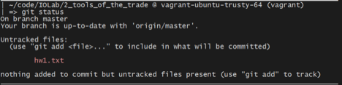

Before you add the homework and submit it, first create a new branch by running:

git checkout –b hw-1-branch

After you create a branch, stage your files, commit, and push the changes to your repository. You can do that by running the following commands:

git add .

git commit –m “ ***\*\*your message here\*\**** ”

git push origin hw-1-branch

As a final step, navigate to your repository on Github’s website. You should see something similar to this page, click on “New Pull Request”.

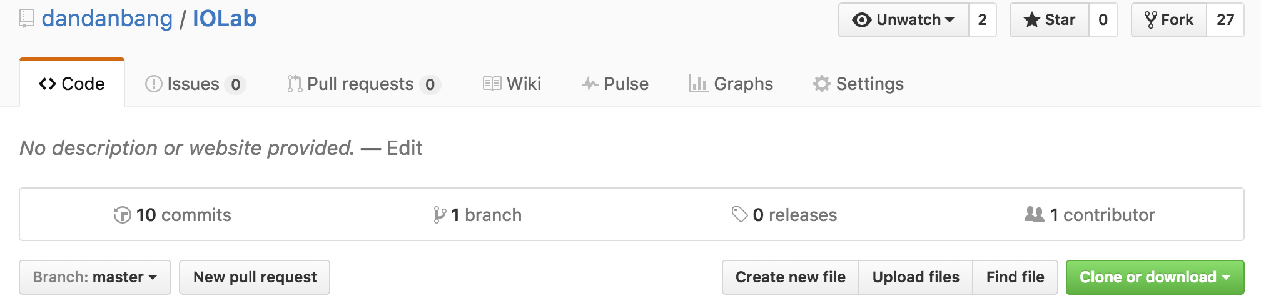

In the following page, you will see something similar to below:

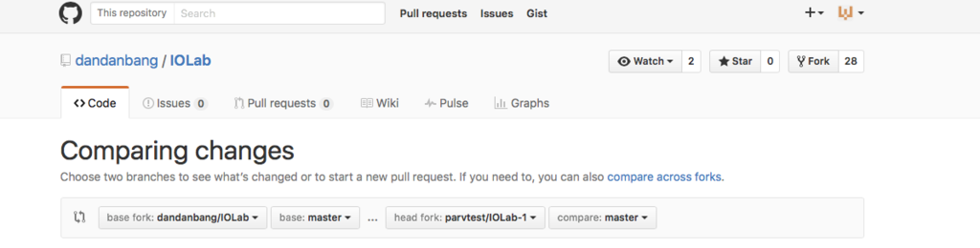

Ensure that you select the base fork as “dandanbang/IOLab” and select the head fork as your own instead of parvsondhi/IOLab, and the branch to hw-1-branch. Finally, you can click “Create Pull Request” to submit your homework.

** The reason for turning in your code in this manner is because it allows to give you pointed feedback on your code inline.  This is a common practice in the industry and is formalized through a process called a code review. If you are interested, you can read more about it here: [http://blog.codeship.com/github-code-review/.](http://blog.codeship.com/github-code-review/)